**Auburn Campus Management System**

Comp 6000 Technical Proposal

**Date**: April 4th, 2016

**Team Member:**

1. Ravinder Putta (rzp0039)

**Introduction:**

Internet has become so indispensable in today‘s world. Application software and mobile applications have become ubiquitous. To design these kinds of applications web technologies play crucial role. One such application, which can automate all the functionalities within our campus, is Auburn Campus Management System (ACMS).

The main aim in developing **ACMS** is to provide an easy way not only to automate all functionalities of our campus, but also to provide full functional reports to top management of the university with the finest of details about any aspect of the campus. It is aimed at providing the latest technologies & trends to the educational institution so that information is synchronized throughout the campus.

This system also helps in improving the flow of information and accessibility to documents across the entire institution by creating a centralized repository that can track a document’s history.

**Architecture**

**Overview of the Project:**

The ACMS systemcan be used to manage the data of all type concerned with educational institutions. It will support both stand-alone and also networking environment. The main modules involved in this system are:

* Login
* Departments
* Users

**Modules Description:**

**Login:**

Login module is used to check whether the user is an authorized person to use the system or not. For this the user should give the correct user name and password.

The different types of users are

* Admin
* Student
* Employee

**Departments:**

Departments’ module shows all the departments and their details within the campus. The data showed on the page is based on the access level of the user.

**Users:**

The users of this application can be either students or staff of the university.

* **Students:**

Students’ module deals with the overall profile of the student and his/her details like courses enrolled, grades, financial aid etc.

* **Staff:**

Staff module will display the information regarding all the teaching and non-teaching staff of the campus.

# Home Page:

This is the main page of the website. This page will have the ACMS logo and options to do the below:

1. Login
2. Register

The Login button will link to the login page. The student or staff need to be already registered to use this login page. The user needs to input the username and password and then submit to log in.

The Register button will redirect the main page to the register page. Here the student or staff need to register by filling out the form. This will store the details in the database. Later when the user will login through the login page, the details will be checked in the database and will be retrieved.

The contents of the HomePage will be done using a XML and the pages will be created using JSP.

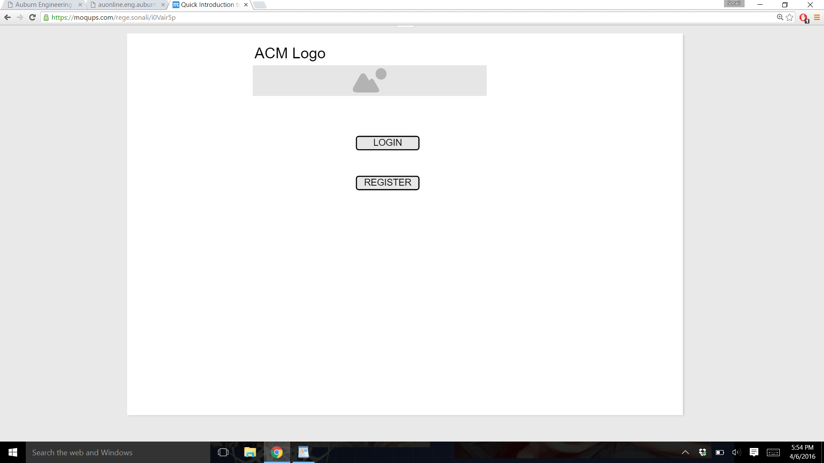

HomePage

# Login Page:

This page will have the textbox for entering the username and the password followed by the submit button. The username will be example: “sda2537”, a combination of alphabets and numeric values. The username will differentiate between students and the staff. The username and password details must match in the database to get redirected to the next page. A validation error message will be shown if the details do not match in the database. There exists a hyperlink to the homepage which redirects to the Homepage.

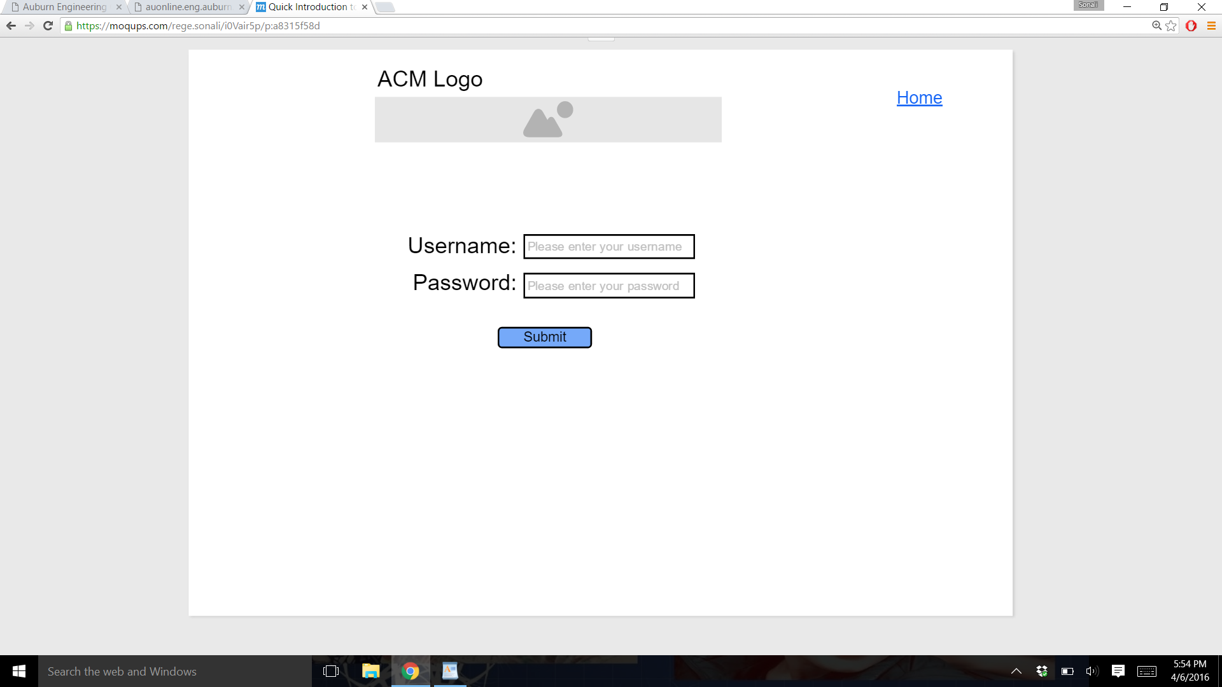

LoginPage

# Registration Page:

The registration page takes the input from the user as shown in the figure below. The details are then stored in the database and retrieved when the username is supposed to check when accessed from the login page. Here, the username is checked if a username with same data is already existing in the MySQL database. If so, then the validation error message is thrown and one cannot register with the particular username. A valid email id is required to be given as input. The birth date needs to be selected from the calendar in the format mm/dd/yyyy. Once a username is registered, it can be then logged in through the login page. There exists a hyperlink to the homepage which redirects to the Homepage.

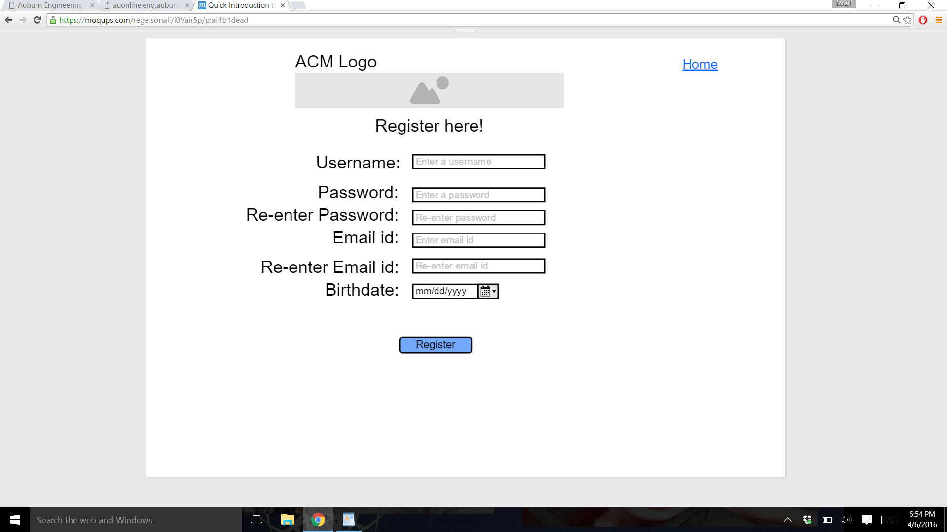

RegistrationPage

**Technologies:**

This system will be developed using the below technologies:

* XML
* JSP
* HTML
* CSS
* MySQL
* Ajax